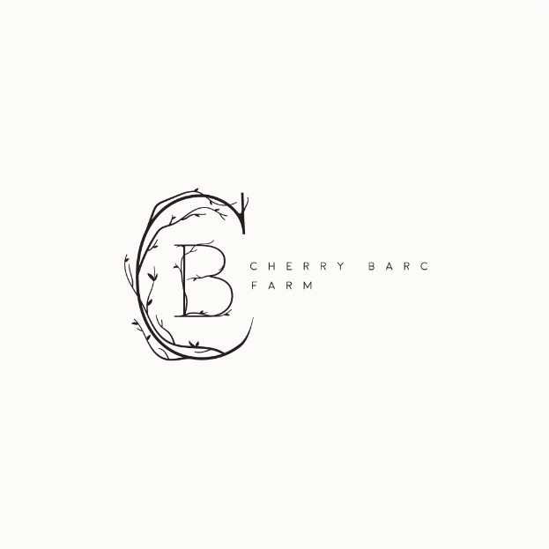
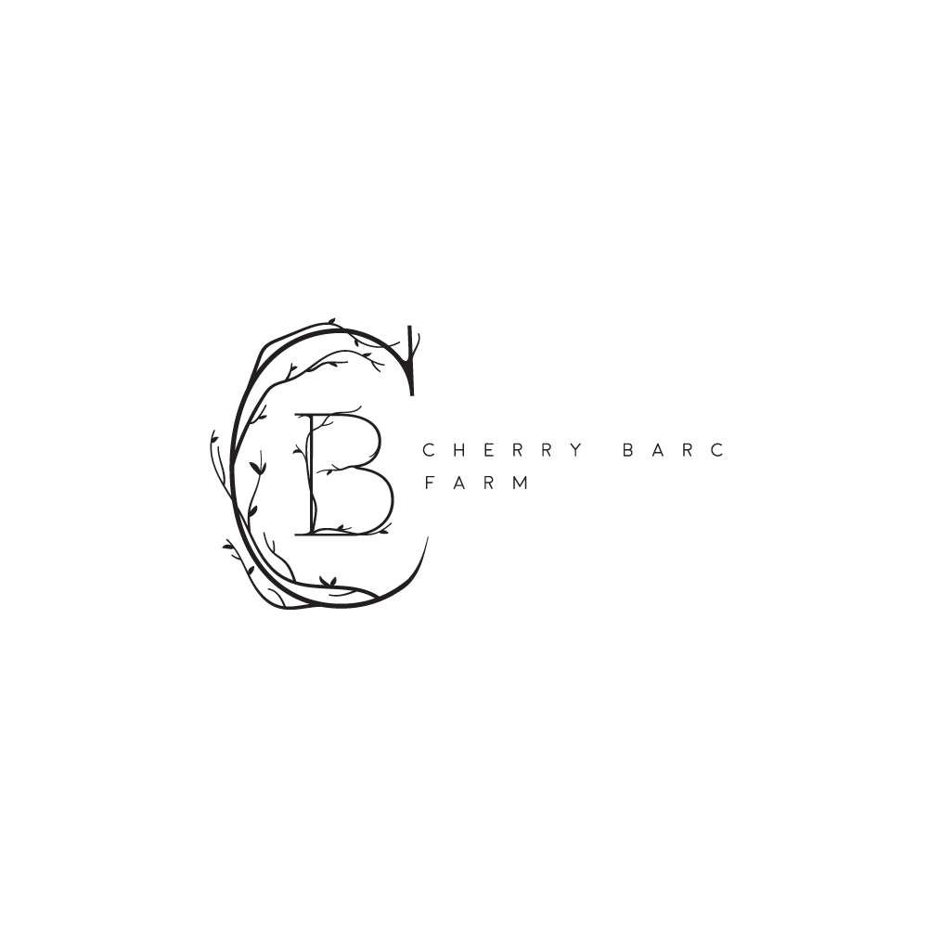
7385 Carlisle Hwy.
Vermontville, MI. 49096
517-703-3936

Reservations require this rental agreement to be signed and dated; accompanied by a non refundable deposit of $2,000. An additional $2,000 is due 6 months before the wedding date. The balance for all rental contracts is due 30 days before your event date along with ceremony start time and table/chair layout. Make checks payable to Cherry Barc Inc. Cherry Barc Farm accepts cash, checks, Visa, and Mastercard.

TOTAL WEEKEND RENTAL PRICE:$6,000.00

Event (couple’s names): _________________________________________________________________________________

Weekend Dates: ______________________

Ceremony & Reception Date:______________________________

TERMS AND CONDITIONS:
1. USE OF PREMISES AND GROUNDS
A. Facility and grounds are only to be used for stated purpose(s). The barn including the grounds is for your use.
B. Set up time starts Friday of the rented weekend at noon-10pm. Saturday time is from 10am -midnight. Sunday clean-up time is from 10am-2pm.
C. All music must end by 11:00 p.m on Saturday. All persons & property must be gone from the property by midnight on Saturday.
D. Candles must be enclosed and in holders that prevent wax from dripping on surfaces.
E. DJs/Bands/Musicians: Please respect that Cherry Barc Farm does have neighbors. Continued use depends upon the goodwill of our neighbors. Loud music will jeopardize our relationship with the community. DJs/Bands/Musicians that abuse our usage rules will not be allowed back.
F. Music cannot be audible beyond the Cherry Barc Farm grounds. Dance Music (90dba) must cease at 11:00pm.
G. Children must always be supervised.
H. Barbecuing is permitted, but only in the circle drive.
I. Tents are permitted on the East and South side of the barn. If heaters are used, they must be placed on concrete or on plywood to protect the grass. Propane heaters are permitted in the barn.
J. No animals are to be brought onto the property. Please tell your guests to leave their pets at home. If animals are brought onto the property, their owners will be asked to remove them. This includes the time for the rehearsal.
K. Fireworks and paper lanterns that are lit and released are NOT permitted under any circumstances.
L. Shoes must be worn by all guests at all times.
M. Paint of any kind is not allowed on the property.
N. Any decorations used on the ground in the outdoor ceremony area must be biodegradable. (i.e. no fake flower petals).
O. DO NOT USE nails, tacks, screws, staples or anything that will penetrate the wood.

2. SET-UP AND BREAKDOWN
A. Cherry Barc Farm will handle the set up and removal of all tables and chairs. Provided linens are a standard white. Colored linens and napkins may be rented for an upcharge due with the final payment. Reception tables and chairs will be set up by 9am the day of the event. Ceremony chairs are placed outside at the discretion of Cherry Barc Farm and weather permitting. All other rented equipment and decorations must be removed the evening of the event. ANY ITEMS LEFT ON THE PREMISE WILL BECOME PROPERTY OF CHERRY BARC FARM WHETHER OWNED BY THE RENTING PARTY OR AN OUTSIDE VENDOR.
B. Cherry Barc Farm provides the tables and all chairs for the ceremony and reception. It is at the discretion of Cherry Barc Farm whether or not to put the ceremony chairs outside. If the weather is unfavorable or rain is in the forecast during the time surrounding the ceremony start time, ceremony chairs will not be placed outside.
C. DO NOT USE nails, tacks, screws, or staples in the walls.
D. Cherry Barc Farm will remove all trash and recyclables throughout the day and when the wedding commences.
E. If signs were placed in area, they must be removed by the renting party.
F. Notify Cherry Barc Farm of any damages that may occur during the event. A $500 security deposit is due 2 weeks before the wedding and can be paid by check or credit card. See security deposit form for specifics.

3. LINENS
All table linens will be provided by Cherry Barc Farm for guest and banquet tables. The round white table linens will be a 90” x 90” square. The renting party may upgrade to 132” round white linens for an additional $10/linen. Banquet table linens will be white 90” x 156”. Colored table linens and overlays may also be rented for an additional charge. Contact Cherry Barc Farm for pricing. Colored napkins may be rented for $0.40 per napkin and white napkins can be rented for $0.30. The renting party will provide the linen count to Cherry Barc Farm no less than 21 days before the wedding date. Any upgrades must be paid for at this time. Contact Cherry Barc Farm for linen order forms.

4. PHOTO BOOTH
Cherry Barc Farm will provide a photo booth, props, and a memory book. The photo booth will have written instruction on use. If the renting party would like the photo booth staffed, they may do so for $50/hour. The photo booth will be set up in the East loft for total of 3 hours. If more time is desired, it can be rented for $75/hour. Additional time can either be arranged and paid for ahead of time or purchased with cash or credit card the day of the event.

5. INDEMNIFICATION AND HOLD HARMLESS AGREEMENT
The Renter agrees to indemnify and hold the Friends of Cherry Barc Farm and the village of Vermontville, its officers and agents harmless from and against any and all liability, claims, actions, demands or losses of any kind and nature that may occur or be claimed with respect to any person or persons, corporation, property of chattels, on or about Cherry Barc Farm, or to the property itself resulting from any act done, or omission by or through the Renter, its agents, contractors, employees, invitees, or any person on the premises of the Cherry Barc Farm by reason of Renter's use or occupancy thereof. These may include, but are not limited to accident, injury or damage to property arising from any act of the Renter or Renter's guest, whether intentional or negligent, which occur during use. Renter agrees to pay all costs and attorney fees incurred by the Cherry Barc Farm owner and representatives in defending any such claim or action brought against the owner and representatives.
By signing this contract, the renting party acknowledges and agrees to abide by all rules including the responsibility of sharing these rules with other vendors and family members. Failure to do so may result in additional fines at the discretion of the owners of Cherry Barc Farm.

6. PERSONAL AND ABANDONED PROPERTY
Cherry Barc Farm and its representatives assume no responsibility for any property placed in the facility or on the premises or any property that is left on the premises after the event is over.

7. CANCELLATION POLICY
A. All cancellations must be in writing.
B. Any wedding not cancelled in writing can be charged the additional fee of $2,000. It is the signing party’s responsibility to pay the fee within 30 days of the no call/no show wedding date.
C. Cancellations made within three (3) days of signing this Rental Agreement: All money paid is refunded.
D. The $1,000 deposit is forfeited if cancellation takes place after the 3 days.
E. Any wedding that needs to be rescheduled to a different date other than the initial one booked, may do so without financial penalty if rescheduled more than 6 months before the booked date. If rescheduling takes place less than 6 months prior to the wedding date, a $500 fee will need to be paid in order to move the wedding date.
F. Any monies paid to Cherry Barc Farm whether payments made towards the wedding throughout the year or the final payment 30 days before the wedding are nonrefundable.
G. Cherry Barc Farm may cancel rentals due to inclement weather, emergency conditions, or events beyond the control of Cherry Barc Farm. In case of cancellation initiated by the Cherry Barc Farm, all rental and deposit monies will be refunded.
H. Any wedding cancelled 2 months or less before the scheduled wedding date will owe all remaining monies.

7. INSURANCE
Renter must provide a Certificate of Liability Insurance 30 days prior to the event whether alcohol is being serve or not. This insurance certificate must explicitly state the following conditions:
A. $1,000,000 Bodily Injury and Property Damage Liability Limits;
B. $1,000,000 Host Liquor Liability must be specifically included in the above coverage;
C. Cherry Barc Farm, its owners, officers, agents, and employees must be named as additional insured for any claim or claims resulting from or growing out of the Renter or event.
Failure to provide evidence of this insurance to Cherry Barc Farm coordinator, 30 days prior to your event, can cause immediate cancellation of your event. Cancellations resulting from failure of renter to provide Cherry Barc Farm with a proper and timely certificate of liability insurance will be treated as a renter caused cancellation occurring less than 30 days prior to the event.

8. ALCOHOL
Renter agrees and warrants that there shall be NO CONSUMPTION OF ALCOHOL BY PERSONS UNDER AGE 21. Renter agrees to refuse to allow alcohol to be served to, or consumed by, any person who is visibly intoxicated or under 21 years of age. Renter shall monitor all service, if any, of alcohol and specifically acknowledges that Renter is solely liable for the consumption of any alcohol by any person on the Premises and that such liability shall extend to any aspect regarding the consumption of alcohol. Cherry Barc Farm may ask guests for identification to verify age and reserves the right to ask to the entire party to leave if (1) a minor is consuming alcohol; (2) an adult is providing alcohol to a minor; or (3) a guest or guests appears intoxicated and refuses to leave the premises.
Renter shall indemnify and hold Cherry Barc Farm harmless from all liability for improper use of alcohol.
All alcohol must be served by a licensed bar tender.

9. BARTENDERS
Cherry Barc Farm will provide 2 bartenders for the hours of 5pm-10:45pm or 3pm to 8:45pm for Sunday weddings. Additional time may be hired for $100/hour and must be arranged no less than 30 days ahead of time. The renting party will provide Cherry Barc Farm with all alcohol, cups, mixers, non-alcoholic beverages, ice, and a list of drinks and/or recipes. The bartenders will also assist in clearing dishes and cups from the tables. A MINIMUM OF $50 GRATUITY IS EXPECTED FOR ALL CHERRY BARC FARM WAIT STAFF FROM THE RENTING PARTY. If gratuity is not provided for wait staff, it will be taken out of the security deposit.

X X
BOTH Renters’ Signature/Date

Name: ___________ Name:_________________________________
Address: __________ Address:________________________________
__________________________________________________________________________________
Phone: ___Phone:__________________________________
Email: _________Email:___________________________________

