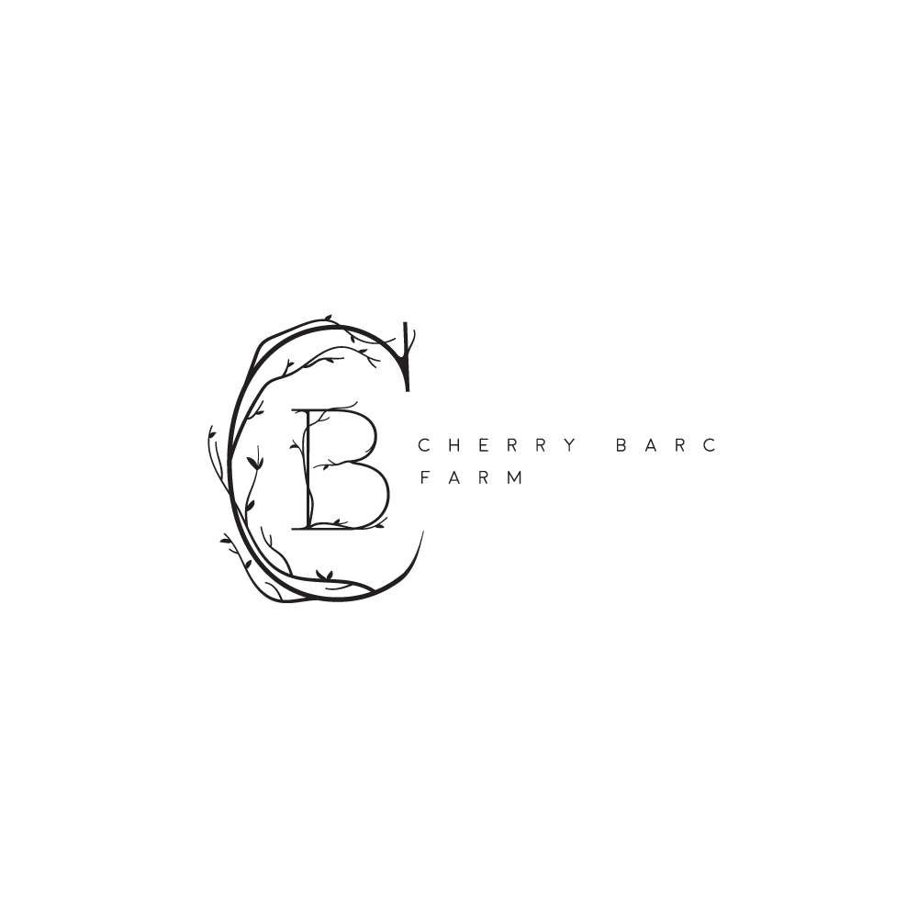

7385 Carlisle Hwy
Vermontville, MI. 49096
517-703-3936
alison@cherrybarcfarm.com
Cherry Barc Farm Security Deposit Form
Cherry Barc Farm requires a $500 security deposit to be paid 30 days prior to the event date. The security deposit may be paid in the form of check, cash, or any major credit card. The deposit will be returned to the renting party 30 days after the event to the address stated below.
In the event an item is missing or something is broken, the repair cost/replacement cost will be calculated and the remaining amount of the security deposit will be returned to the renting party along with an invoice of the damage/missing item. If the damages are greater than $500, an invoice will be sent to the renting party and to be paid no more than 30 days after receiving said invoice. It is the renting party’s responsibility to make sure all items supplied by Cherry Barc Farm are returned to them including but not limited to tables, chairs, dollies, extension cords, bottle openers, scissors etc that are either borrowed by the renting party, guests, or other vendors. There is a $100/per incident fee charged for cleanup of any bodily fluids outside the toilet of the barns. The security deposit will also cover damages including, but not limited to damage to the barn and/or arbor caused by nails/screw or any unapproved hooks, damages to tables/chairs, damages to landscaping/flowers/fruit/animals, damages and inconveniences caused to the owners/works from the renting party breaking contract rules, and any other property owned by Cherry Barc Farm and Nicholas and Alison Barc. If gratuity for C.B.F. wait staff is not provided, it will be taken out of the security deposit. It is the renting party’s responsibility to make sure all guests/vendors are aware of Cherry Barc Farms rules and follow them.
Agreement by Signature
Signature indicates the Renter agrees to all terms and conditions stated herein.

X
Renters’ Signature

Name: ___________ Wedding Date:__________________________
Address: __________ _________________________________________
Phone: __
Email: _________

